ENG101
November 2015
Practice Exam

ملاحظة هامة:
يمنع منعا باتا الكتابة على ورقة الأسئلة ولن تحتسب أي إجابة مكتوبة على ورقة الأسئلة.
ستعتمد فقط الإجابات المظللة على ورقة الإجابة

Name: | ……………………………………………………………
Student No:
  0 | 0 | 0
Section No:

This practice test has 7 sections.
Section 1 – Reading (6 items = 6 marks)
Section 2 - Writing (2 items = 2 marks)
Section 3 – Critical Thinking (2 items = 2 marks)
Section 4 - Speaking (2 items = 2 marks)
Section 5 – Pronunciation (2 items = 2 marks)
Section 6 – Listening (6 items = 6 marks)
Section 7 – Language Use (20 items = 20 marks)

SECTION 1: READING
Read the article and look at the table, then answer the questions that follow.
Culture and Life Magazine
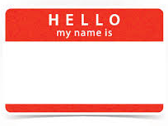 | ¹Do you like your name? There are many ways to choose a name for a child. Naming traditions are different all over the world. Some people are named after a family member. In some cultures, the baby is not named by the parents. These different traditions are very interesting.  ²Last week we asked our readers to tell us about their names. We got some interesting responses!

³ My name is Jian Shen Wong. Most Chinese names have three parts: the family name, the generation name, and the first name. My last name comes from my father’s family. My generation name comes from the words in a poem. Traditionally, each family has its own “generation poem.” My first name, Jian, means to see. I like my first name. It is a common name in China. It is also easy for people who are not Chinese to say.
Jian Shen Wong, China
⁴ Hello! My name is Salih Ahmad Al Hajj. In Tunisia, your middle name is always your father’s name. All of my brothers and sisters have the middle name Ahmad. I love my first name. My uncle is also called Salih. It is a popular name in my city. The name means righteous. I want to name my son Salih. My family name is also common in Tunisia.

Salih Ahmad Al Hajj, Tunisia

⁵ Hello. My name is Joe King. I do not like my name. Children at school use to laugh at my name. My grandfather was called Joe. He was a funny man. My full name gets a lot of attention, and it is easy to say. It is a unique name. However, I want to change it.

Joe King, England

⁶ In Spain, a name usually has three parts: the first name, the father’s last name, and the mother’s last name. The father’s last name is used from one generation to the next. The mother’s last name goes only to one generation. Traditionally, parents give their children the grandparents’ first names. My grandfather is called Sergio. I like my name. It sounds nice and many famous people in Spain have my name.

Sergio Rodriguez Garcia, Spain

⁷ My first name is Kavonte. I love my name because it is unique. My parents created this name. Many African American parents create interesting names that sound nice. My parents created my brothers’ and sisters’ names, too. They first choose a popular name, and then they change it a little to make it interesting. My little sister is called LaMaria.

Kavonte Champ Bailey, U.S.A.
Popular Boys Names in the UK 2015
Name | Number of babies
Oliver | 6,649
Jack | 5,804
Harry | 5,379
Jacob | 5,050

- Which of the following sentences is a supporting sentence in paragraph 1?
- These different traditions are very interesting.
- My generation name comes from the words in a poem.
- There are many ways to choose a name for a child.
- Some people are named after a family member.

- What can you infer about Salih?
- His father is not alive.
- He is married.
- Salih and his uncle live in the same city.
- He has three brothers and two sisters.

- According to the table, ____________ people named their babies Harry in the UK in 2015.
- 6,649
- 5,379
- 5,804
- 5,050

Read the following story then answer the questions that follow.
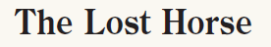
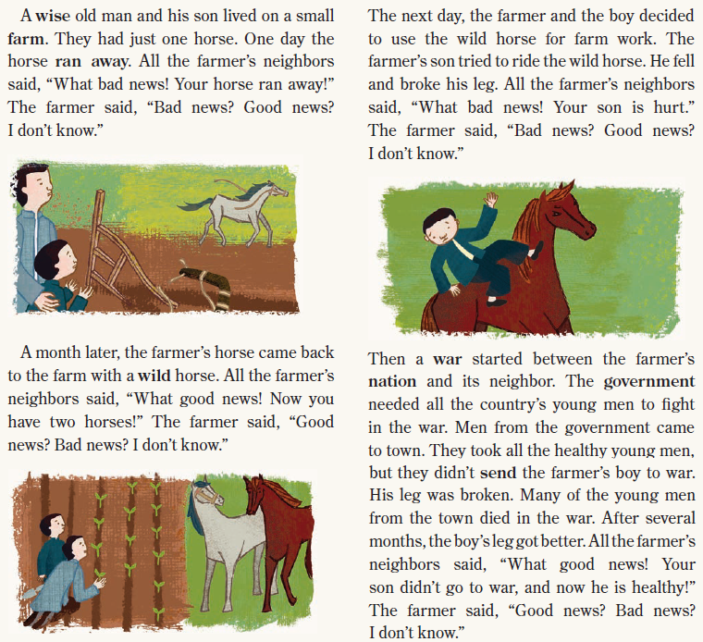

- The farmer's son fell off the wild horse and broke his________________.
- arm
- neck
- back
- leg

- Men from the government took ___________________ for the war.
- the healthy young men
- the farmer's son
- all of the neighbors
- the wise old man and his son

- Who doesn't think news is good or bad?
- the wise old man
- the son
- all of the neighbors
- the wise old man and his son

SECTION 2: WRITING
Answer the following questions:

- Which of the following sentences is not capitalized correctly?

- There are thirty days in the month of April.
- New Zealand is a beautiful country.
- I like to go shopping on Sultana street.
- Applebee's is a popular restaurant in Madinah.

- What is the best topic sentence for the paragraph below?

______________________________. Some sports are new. Skateboarding, for example, only started in the 1950s. Other sports have existed for a long time. People have played different forms of soccer for at least 2,000 years. It is interesting to find out about the sports you play.

- New sports are more fun than old sports.
- Many people don't know the history of their favorite sports.
- Soccer is the oldest sport in the world.
- It is not important to know the history of the sports you play.

SECTION 3: CRITICAL THINKING
Answer the following questions:
- Read the paragraph below. Then select the option which is true.

¹My name is Carlos. ²When I was a boy, I was a Barcelona fan. ³I went to lots of games with my father. ⁴We always took snacks and juice, and we had lots of fun. ⁵I have some of my old Barcelona clothes. ⁶They don't fit me now, but my son likes them . ⁷Now, I watch games with my son. ⁸We go to the stadium once a month. ⁹My whole family loves Barcelona.

- Sentence 1 is the topic sentence. Sentence 4 is a supporting sentence.
- Sentence 3 is the topic sentence. Sentence 4 is a supporting sentence.
- Sentence 2 is the topic sentence. Sentence 3 is a supporting sentence.
- Sentence 3 is a supporting sentence. Sentence 5 is a detail.

- Read the paragraph below. According to the paragraph, which of the following people's interests match a career as a doctor?

It is important that your skills and interests match your career. Happy workers have more success. For example, if you want to be a doctor, you should like to solve problems. You should also like to learn new information. You should like studying science. You should also not mind working long hours. Think carefully before you choose your career.

- "I do not like learning new things. I like to be outside."
- "I love to figure out the answer to problems. I also love biology."
- "I would like to be my own boss. Then I can work short hours."
- "I like to help people. I love studying geography, but I don't like chemistry."

SECTION 4: SPEAKING
- Complete the dialogue with the correct response.
A: My best friend had an accident yesterday.
B: ______________.
- I see.
- That's interesting.
- Wow
- That's too bad.
- In a presentation, you say "______________" to change to a new topic.
- Let's start with…
- To wrap up, I'll tell you about…
- Next, I'm going to explain…
- The first thing I'm going to talk about…
SECTION 5: PRONUNCIATION
- Listen to the word 'attitude' and choose the correct number of syllables.
- 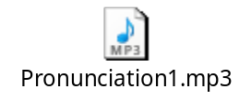three syllables
- four syllables
- two syllables
- five syllables

- Which of the following words ends in an /s/ sound?
- 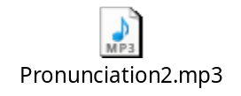gives
- laughs
- washes
- says

SECTION 6: LISTENING
Listening 1

- Wendy Smith thinks that __________ is the reason for students’ dishonesty.
- technology
- cheating
- advertising
- sending messages

- The students handed in reports that they copied from __________.
- each other
- their cell phones
- the Internet
- their books

- Because of the students’ cheating, Wendy Smith __________.
- reported them
- took students’ cell phones during tests
- prevented students from using the Internet
- gave all them a zero

Listening 2

- Humans were playing and practicing sports over ____________ years ago.
- four hundred
- four million
- four thousand
- four

- Dr. Wilkins says “__________ are important skills for life.”
- bringing people together and making new friends
- going to school and working hard
- watching sports live and on TV
- being part of a team and working together

- This conversation is about _________.
- the advantages of doing sports
- sports around the world
- how to learn a new sport
- team work

SECTION 7: LANGUAGE USE
- In some countries, every child ______ the father's given name.
- getting
- gets
- get
- to get

- What did you _______ when you said, 'the food is not hot'?
- means
- meant
- mean
- meaning

- Fahad doesn't want ______ his friend's feelings.
- hurts
- hurt
- hurting
- to hurt

- Last summer, my lawn was sandy. Now there ______ a lot of grass in front of my house.
- is
- were
- was
- are

- In some cultures, it's polite ______ off your shoes when you enter someone's house.
- takes
- to take
- take
- to taking

- Khaled was late for work today _______ there was a lot of traffic.
- so
- as a result
- because
- therefore

- Are the volunteers going _______ a school in Khaibar?
- repair
- repairs
- repairing
- to repair

- A father visits his son who studies in Jeddah. He asks him, "How can you sleep with these noisy roommates?" The son _______, '' I just lie in bed and turn on the radio very loud.''
- replies
- reply
- replying
- to reply

- Omar believes that ________ basketball is really fun.
- play
- playing
- plays
- to playing

- Let's play soccer _____ Al Ansar Soccer Club.
- on
- of
- at
- off

- Which group of words is in alphabetical order?
- their, then, there, the
- moon, more, mount, mother
- chair, cheap, choose, child
- after, also, ant, any

- It's really ________ to copy the school report from the Internet.
- dishonest
- unhonest
- mishonest
- imhonest

- In which of the following sentences is the word 'tour' a verb?
- A walking tour of Jeddah in the summer is not a good idea.
- We decided to tour the old city of Yanbu this summer.
- A guided and well planned tour will help get more customers.
- The Saudi soccer team's tour of Malaysia was really fun.

- My English friend didn't understand Arabic well when he visited Riyadh. When people spoke, he felt ________. But he still had a great time.
- cheerful
- positive
- confused
- optimistic

- I had a very bad headache, and all the medicines I took were ________.
- ineffectively
- effect
- ineffective
- effectively

- Bandar is driving too fast. He needs to _______ or he might get a ticket.
- speak up
- come over
- look through
- slow down

- If you go to Jazan, you should visit Farasan Island. The nature there is _______.
- amazing
- amazed
- amazes
- amazingly

- Yuna was really __________ when everyone laughed at her.
- embarrasses
- embarrassed
- embarrassment
- embarrassingly

- What is the synonym of the word 'trouble, in the following sentence? My grandparents have troubles with their loud neighbors.
- punishments
- impressions
- problems
- reputations

- Which definition gives the meaning of the word 'control' in the following sentence? 'Davidson lost control of himself and started shouting at everyone of us.'

- the people who direct an activity or who check that something is done correctly
- the ability or power to make someone or something do what you want or make something happen in the way you want
- a thing that you already know the result for that is used in a scientific test, in order to show that your method is working correctly
- the ability to remain calm even when you feel very angry, upset, or excited:

