Book 1 Unit 8
Honesty/Dishonesty/Is it ever okay to lie?
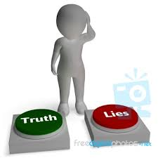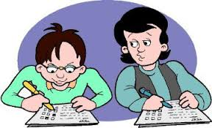
Book 1 Unit 9
Is it ever too late to change?/ How are children and adults different?


Book 1 Unit 10
When is it good to be afraid?/ What are you afraid of?
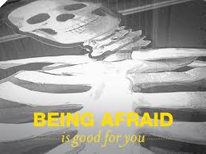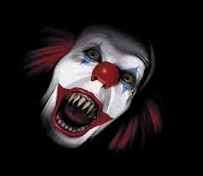
Book 2 Unit 1
What are current trends in architecture? / Why does something become popular?

Book 2 Unit 2
How can colors be useful? How do colors affect the way we feel?
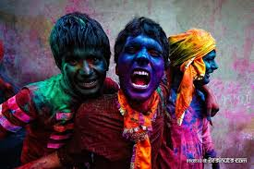
Book 2 Unit 3
Why are good manners important? What does it mean to be polite?
